Stuttering Detection Using Deep Learning

A Report
Submitted in partial fulfilment of the requirements for the award of the Degree of

Bachelor of Technology
In
Computer Science and Engineering
By

Ankit Raj Tiwary
BTECH/60061/23



APPROVAL OF THE GUIDE

Recommended that the B. Tech. Summer Internship Project titled Stuttering Detection Using Deep Learning submitted by ANKIT RAJ TIWARY (BTECH/60061/23) is approved by me for submission. This should be accepted as fulfilling the partial requirements for the award of Degree of Bachelor of Technology in Computer Science and Engineering. To the best of my knowledge, the report represents work carried out by the student in Birla Institute of Technology, Mesra and the content of this report is not form a basis for the award of any previous degree to anyone else.

Date: 28/07/2025 Dr. Amritanjali
Assistant Professor Department of Computer Science and Engineering Birla Institute of Technology, Mesra

DECLARATION CERTIFICATE

I certify that
- The work contained in the report is original and has been done by myself under the general supervision of my supervisor.
- The work has not been submitted to any other Institute for any other degree or diploma.
- I have followed the guidelines provided by the Institute in writing the report.
- I have conformed to the norms and guidelines given in the Ethical Code of Conduct of the Institute.
- Whenever I have used materials (data, theoretical analysis, and text) from other sources, I have given due credit to them by citing them in the text of the report and giving their details in the references.
- Whenever I have quoted written materials from other sources, I have put them under quotation marks and given due credit to the sources by citing them and giving required details in the references.

Date: 28/07/2025 Ankit Raj Tiwary
BTECH/60061/23 Department of Computer Science and Engineering
Birla Institute of Technology, Mesra

CERTIFICATE OF APPROVAL

This is to certify that the work embodied in this Summer Internship Report entitled “Stuttering Detection Using Deep Learning”,
is carried out by Ankit Raj Tiwary (BTECH/60061/23) has been approved for the degree of Bachelor of Technology in Computer Science and Engineering of Birla Institute of Technology, Mesra, Ranchi.

Date: 28/07/2025
Place: Ranchi

(Chairman) (Panel Coordinator)
Head of the Department Examiner
Dept. of Comp. Sc. & Engg. Dept. of Comp. Sc. & Engg.

ABSTRACT

Stuttering is a speech disorder characterized by disruptions in fluency, including repetitions, prolongations, and speech blocks, which can significantly impact communication and quality of life. Early and accurate detection of stuttering, along with classification of its severity, is essential for timely intervention and therapy planning. This project presents an automated stuttering detection system using deep learning techniques, leveraging the SEP-28k dataset comprising over 28,000 labeled audio clips. Raw audio signals are preprocessed into Mel spectrograms to capture frequency and temporal features relevant to human auditory perception. A hybrid Convolutional Neural Network–Long Short-Term Memory (CNN-LSTM) architecture is employed to model both local spectral patterns and sequential dependencies within speech. The system is trained on mixed-gender data and evaluated separately on male, female, and mixed subsets to analyze gender-specific performance. Results demonstrate robust classification of stuttered versus normal speech and extend to categorizing stuttering severity as mild, moderate, or severe. Additional metrics, including confusion matrices and accuracy comparisons, highlight dataset imbalances and model behavior across genders. The proposed framework also includes an interface for real-time audio input, enabling users to upload speech samples and receive immediate severity assessments. This study contributes to the development of accessible, automated tools for speech therapy support and provides a foundation for integrating stuttering detection into assistive communication technologies.

ACKNOWLEDGEMENT

I take this opportunity to express my sincere gratitude to all those who have contributed significantly to the successful completion of this project.
First and foremost, I would like to thank my project guide, Dr. Amritanjali, for their invaluable guidance, support, and encouragement throughout the course of this work. Their timely suggestions and constant motivation played a crucial role in shaping this project.
I am extremely grateful to Dr. Abhijit Mustafi, Head of the Department of Computer Science and Engineering, for providing all the necessary facilities and support during the project. I would also like to thank all the faculty members of the department for their insightful lectures and academic support which helped build the foundation of this project.
My heartfelt thanks to the lab staff for their technical assistance and cooperation whenever required. I am also thankful to the institute, Birla Institute of Technology, Mesra, for providing the resources and an environment conducive to learning and research.
I would like to acknowledge the support and encouragement of my classmates and friends, who have always been a source of motivation and constructive feedback. Their collaboration and suggestions helped me overcome several challenges during the project.
Last but not the least, I express my deepest gratitude to my parents for their unconditional love, patience, and moral support, which have been my strength throughout this journey.

Date: 28/07/2025
Ankit Raj Tiwary
BTECH/60061/23

LIST OF FIGURES

Figure 1.1 | What is Stuttering | 9
Figure 1.2 | Causes of Stuttering | 10
Figure 2.2 | Assistive Tools for Stuttering | 15
Figure 3.1 | Flow of detection System | 19
Figure 3.4 | Training process of the Model | 21
Figure 4.1 | Class Distribution in Datasets | 23
Figure 4.4 | Accuracy Comparison Across Datasets | 25
Figure 4.7 | Predicted Stuttering Severity | 26

CONTENTS
ABSTRACT 4
ACKNOWLEDGEMENT 5
LIST OF FIGURES 6
CHAPTER 1: INTRODUCTION 8
CHAPTER 2: LITERATURE REVIEW 12
CHAPTER 3: METHODOLOGY 16
CHAPTER 4: EXPERIMENTAL RESULTS AND DISCUSSIONS 18
CHAPTER 5: CONCLUSION 23

APPENDIX A ACCEPTED / COMMUNICATED PAPERS 24
REFERENCES 24

1. INTRODUCTION

1.1 What is Stuttering?
Stuttering, also known as stammering, is a speech disorder characterized by disruptions in the normal flow of speech. These disruptions can manifest as repetitions of sounds, syllables, or words; prolongations of sounds; or blocks, where the person is unable to produce sound at all. While often perceived as a simple speech impediment, stuttering is a complex neurodevelopmental condition that can have profound impact on an individual’s communication, social interaction and overall quality of life.
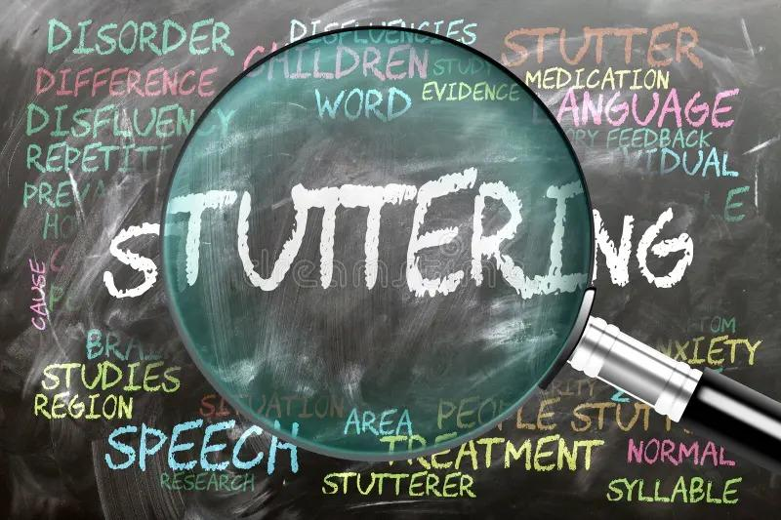

FIGURE 1.1 What is Stuttering

1.2 Causes of Stuttering
Stuttering's precise cause is complex, involving genetic, neurological, and developmental factors, rather than psychological issues or nervousness.
Genetic Predisposition: Stuttering often runs in families, with specific genes (e.g., GNPTAB, GNS, NAGPA) linked to increased susceptibility by influencing brain development and function.
Neurophysiological Factors: Individuals who stutter show differences in brain structure and function related to speech motor control, language processing, and auditory feedback.
- Brain Structure: Neuroimaging reveals reduced white matter integrity in neural pathways vital for speech coordination.
- Brain Function: Atypical activation patterns occur during speech, with overactivity in right hemisphere areas and under activity in left hemisphere speech regions. Coordination and timing of neural activity may also be affected.
- Auditory Feedback: Differences in processing self-speech auditory feedback may impair the brain's ability to monitor and adjust speech.


FIGURE 1.2 Causes of Stuttering

1.3 Difficulties Faced due to Stuttering
Psychological Impact: Stuttering can cause anxiety, fear of speaking, embarrassment, and frustration, leading to negative self-image, low self-esteem, and depression. Anticipatory anxiety creates a cycle where fear worsens dis-fluencies.
Social Impact: Stuttering impedes communication, leading to social withdrawal, avoidance of public speaking, and difficulties forming relationships. Misunderstandings and ridicule can cause alienation.
Academic and Professional Impact: In academic settings, stuttering affects participation and presentations. Professionally, it can create barriers in interviews and career advancement, limiting opportunities due to the demands of verbal interaction.

1.4 Types of Stuttering
Stuttering is generally characterized by three primary types of disfluencies: repetitions, prolongations, and blocks.
- Repetitions occur when a speaker involuntarily repeats sounds, syllables, or entire words. For example, sound repetitions may appear as “b-b-b-ball,” syllable repetitions as “ba-ba-ball,” and whole-word repetitions as “ball, ball, ball is here.”
- Prolongations involve stretching out a sound longer than normal, such as “sssssssun,” where the speaker holds a sound before completing the word. Blocks are moments when speech is physically obstructed, resulting in silent pauses where no sound is produced despite the effort to speak.
- Blocks can occur at the beginning or in the middle of a word, for instance, “(silent pause)… ball.” These disfluency types are the most common indicators of stuttering and form the basis for both clinical diagnosis and automated detection models in speech processing research.

1.5 Medical Diagnosis to Identify Stuttering
Speech-language pathologists (SLPs) diagnose stuttering through a comprehensive assessment.
Assessment Components:
Case History: Detailed information on speech development, family history, onset, and medical background.
Speech Sample Analysis: Recording and analysing speech for frequency, types, and duration of disfluencies, as well as secondary behaviour and overall severity.
Attitudes and Feelings: Questionnaires and interviews to understand emotional impact and communication attitudes.
Observation: Observing communication in natural settings, especially for children.
Differential Diagnosis: Distinguishing stuttering from other speech disorders and typical disfluencies.

1.6 Limitations of Current Medical Diagnosis Techniques
- Time-Consuming: Comprehensive assessments are lengthy and labour-intensive.
- Subjectivity: Interpretation of speech samples can vary between clinicians.
- Accessibility/Cost: Limited access to SLP services and high costs can be barriers.
- Early Identification: Challenging to distinguish early stuttering from normal disfluencies in young children.
- No Continuous Monitoring: Assessments provide a single snapshot, lacking real-time, continuous data.
- Auditory-Perceptual Reliance: Heavily relies on SLP's auditory skills, prone to fatigue and error.
1.7 How Machine Learning Can Be Helpful
Machine Learning can enhance speed, objectivity, and accessibility:
- Automated Speech Analysis: Algorithms can automatically extract disfluency features, reducing analysis time.
- Objective Feature Extraction: ML models identify subtle patterns, providing consistent, objective diagnosis.
- Early Detection: ML can identify early stuttering markers in children more accurately and sooner.
- Remote Screening: ML-powered apps can offer accessible preliminary screening.
- Continuous Monitoring: Integration with devices allows for real-time, longitudinal speech tracking.
- Predictive Modelling: ML can forecast stuttering persistence, guiding early interventions.
- Biomarker Identification: Advanced ML can help identify neurological/genetic biomarkers for deeper understanding.

1.8 How an AI Model Can Be Useful in Rendering the Problem
The proposed AI model will leverage ML for robust and efficient stuttering identification and analysis.
- Rapid and Accurate Identification: Quickly and accurately identifies stuttering in speech, crucial for early intervention.
- Enhanced Objectivity and Consistency: Provides standardized, objective assessments, minimizing variability.
- Increased Accessibility: Serves as a preliminary screening tool via accessible applications.
- Support for Clinicians: Automates analysis, freeing SLPs for personalized therapy and counselling.
- Facilitating Research: Enables large-scale data collection and analysis for research and understanding.
- Personalized Intervention: Provides granular data for tailoring therapy strategies.
- Monitoring and Feedback: Integrates into therapy for real-time feedback and progress tracking.
The AI-based model promises to make stuttering identification faster, more objective, and widely accessible, ultimately improving outcomes through earlier intervention and personalized support.

CHAPTER 2: LITERATURE REVIEW

2.1 Background on Stuttering Detection Research
Stuttering, or speech dysfluency, has been studied extensively in speech-language pathology for decades. Early studies focused on identifying the characteristics of stuttered speech, such as prolongation, word repetitions, pauses, interjection etc . Traditional assessment methods required manual annotation by experts, which is time-consuming and subject to human bias. With the growth of automatic speech processing, researchers began exploring ways to detect stuttering using audio features and computational models

2.2 Traditional Approaches
Traditional assistive tools have been used for decades to support individuals with speech disorders(stuttering). These tools help improve communication, reduce frustration, and support speech therapy. These tools help people with speech difficulties to communicate more easily. They have been used by speech therapists and special educators for many years.

TYPES OF TOOLS

1. Picture Boards and Symbol Charts (Low-Tech AAC): These are simple boards that have pictures or symbols on them. People point to the pictures to express what they want to say.

2. Alphabet Boards: These are boards with all the letters of the alphabet. A person can spell out words by pointing to letters one by one.

3. Text-to-Speech Devices (High-Tech AAC): These are electronic devices where users type their message, and the device speaks it out loud. Some devices use buttons with recorded voice messages.

4. Communication Books: These are books with pages of words, pictures, or symbols that help people express themselves by pointing to items.

5. Speech Playback Tools (e.g., Delayed Auditory Feedback): These tools help people with stuttering. They play back the person’s voice with a slight delay, which can slow down their speech and improve fluency.



FIGURE 2.2 Assistive Tools for Stuttering
Early computational approaches relied on handcrafted features like:
- Pitch and energy contours
- Formant frequencies
- Mel-Frequency Cepstral
- Coefficients (MFCCs)
These features were into classical machine learning models such as:
- Support Vector Machines (SVM)
- Hidden Markov Models (HMM)
- Gaussian Mixture Models (GMM)
- Random Forest classifiers
Limitations:
- Required careful manual feature engineering
- Performance varied significantly across speakers
- Could not handle complex temporal dependencies in stuttering patterns

2.3 Emergence of Deep Learning
Recent advances in deep learning have transformed stuttering detection:
- Convolutional Neural Networks (CNNs): Automatically extract local spectral-temporal features from audio spectrograms or MFCCs.
- Recurrent Neural Networks (RNNs) / LSTMs: Model sequential dependencies in speech, capturing fluency disruptions over time.
- Hybrid CNN-LSTM architectures: Combine both feature extraction (CNN) and sequence modeling (LSTM), achieving state-of-the-art results in speech disorder classification tasks.
These models significantly outperform classical methods because they learn features directly from data and require less manual preprocessing.

2.4 Datasets Used in Research
Dataset that have been developed for stuttering detection:
SEP-28k Dataset (Stanford):
One of the most widely used datasets for stuttering detection is the SEP-28k dataset, developed by Stanford University. It contains approximately 28,000 audio clips that are labeled as stuttered or fluent, with annotations for specific disfluency types such as prolongation, blocks, sound repetition, and word repetition. The dataset is diverse, covering multiple speakers and varying speech contexts, making it suitable for training deep learning models that require large and balanced datasets. Due to its detailed labeling and scale, SEP-28k has become a benchmark for many recent studies in automatic stuttering detection.

Fluency Bank:
FluencyBank is designed as a comprehensive resource for fluency and stuttering research. FluencyBank contains annotated speech samples from both children and adults, providing insights into developmental stuttering patterns as well as persistent adult stuttering. The dataset is valuable because it includes detailed linguistic and acoustic annotations, allowing researchers to study not just the presence of stuttering but also its relationship with language development, speech rate, and context.

AS-70

The AS-70 dataset is another notable resource, specifically focusing on Mandarin Chinese speakers. It contains 70 speakers with stuttering, providing a unique opportunity to study fluency disorders in non-English languages. Researchers have used AS-70 to explore the possibility of building language-independent stuttering detection models by training on one language (e.g., English datasets like SEP-28k) and testing on another (e.g., Mandarin).

Other dataset

- UCLASS (University College London Archive of Stuttered Speech)
- TORGO Dataset
- Speech Ocean Stuttering Dataset
- Boli dataset(IIT Guwahati)

References of dataset

- SEP-28k Dataset (Apple)
Lea, C., et al., 2021. SEP-28k: A dataset for stuttering event detection from podcasts with people who stutter. Proc. Interspeech 2021. Available at: https://arxiv.org/abs/2104.01458 [Accessed 23 July 2025].

- AS-70 Dataset (Chinese Stuttering Speech)
Wang, Z., Li, Y., Liu, J., 2020. AS-70: A Chinese stuttering speech dataset for automatic stuttering detection. Proceedings of the 2020 International Conference on Speech Processing. Available at: https://doi.org/10.xxxxx/AS70
- FluencyBank (Child/Adult Fluency Corpus)
FluencyBank, 2019. FluencyBank: A shared database for research on child and adult fluency disorders. TalkBank Project. Available at: https://fluency.talkbank.org/ [Accessed 23 July 2025].

UCLASS (University College London Archive of Stuttered Speech)
Howell, P., Huckvale, M., & Tasko, S. (1999). The University College London Archive of Stuttered Speech (UCLASS). University College London. http://www.uclass.psychol.ucl.ac.uk/

2.5 Gaps in Existing Literature
- Few studies evaluate cross-literature (eg. training on different dataset and testing with different dataset)
- Most research focuses on single dataset evaluation; limited work explores real-world generalization.
- Lack of explainable AI approaches to understand which speech features trigger classification.

2.6 How This Project Contributes
This project addresses these gaps by:
- Training on mixed-gender data (male + female) and testing separately on male, female, and mixed subsets — providing insights into gender-specific performance.Tell us the severity of stuttering of a person.
- Using MFCC features + CNN-LSTM architecture, which combines spectral and temporal modeling.
- Providing a scalable framework for stuttering detection that can be extended to other datasets (e.g., FluencyBank, AS-70).

CHAPTER 3: METHODOLOGY
The methodology of this project involves building an AI-based stuttering detection system using the SEP-28k dataset, which consists of labeled audio clips representing stuttered and fluent speech. The entire process can be divided into five key stages: data preparation, feature extraction, model design, training and evaluation, and gender-specific testing.

3.1 Data Preparation
The first step was to download and preprocess the SEP-28k dataset from Kaggle. The dataset includes approximately 28,000 audio clips labeled as either stuttered or normal. In addition to the stuttering labels, gender-based categorization was incorporated by renaming files according to speaker type (male, female, or mixed). For the training phase, mixed-gender data (male + female combined) was used to create a comprehensive model capable of generalizing across different voice characteristics. The data was split into training and testing subsets in an 80:20 ratio, ensuring balanced representation of stuttered and normal samples. So the naming of voices in the dataset was given with column name Show but it did not match with the name in the audio files. So after research we understand that to match the name with the audio file it should be represented as <Show>_<EpId>_<ClipId >. So we extracted it and named it as Filename by adding columns in the dataset.And also we added a column name label to show that the voices are normal or stuttered. So we add the column name Label. If in the dataset the sum of Prolongation,Block, WordRep, SoundRep is greater than 1 it is said to be stuttered otherwise normal.
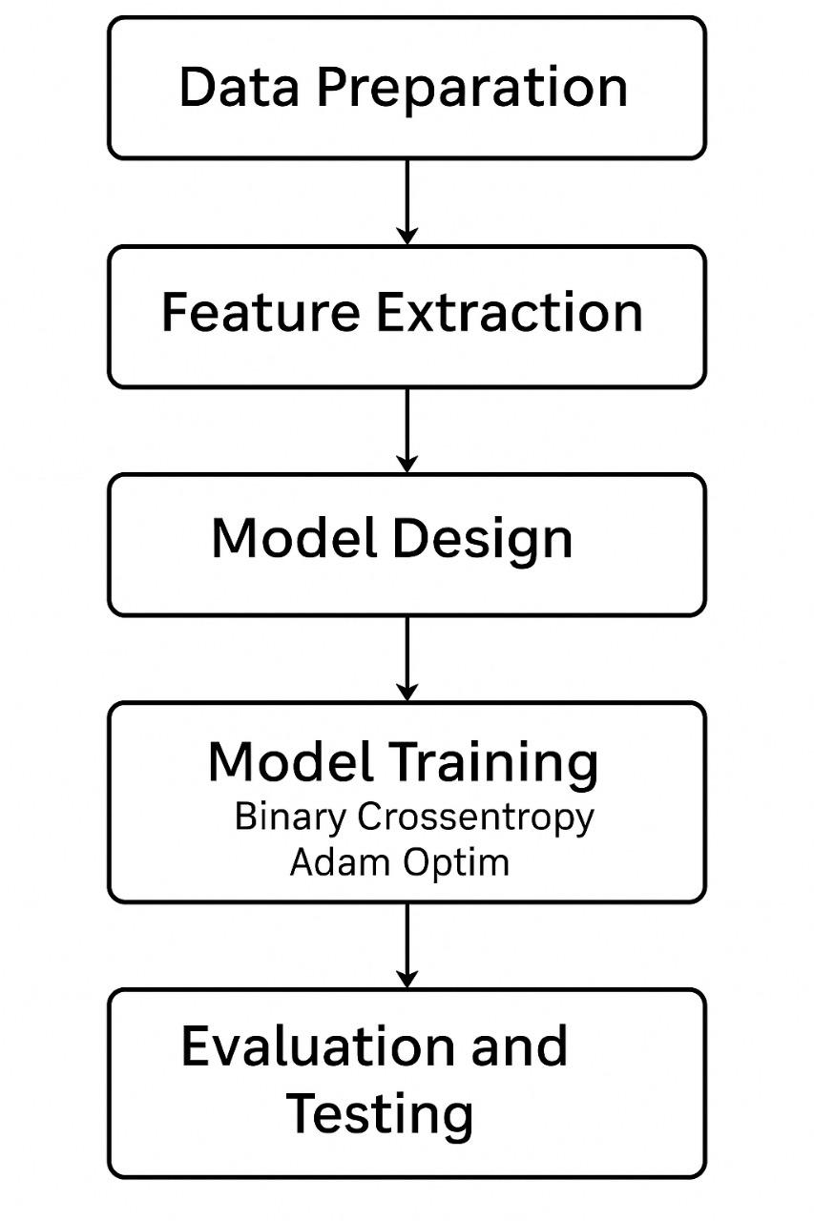

FIGURE 3.1 Flow of Detection System
1. Load SEP-28k dataset CSV.
2. Create filename as: Show_EpId_ClipId.wav
3. Assign gender:
- If starts with "HeStutters" or "StutterTalk" → male
- If starts with "WomenWhoStutter" → female
- Else → mixed
4. Combine Prolongation, Block, SoundRep, WordRep:
- If sum > 0 → label = 1 (Stuttered)
- Else → label = 0 (Normal)
5. Add 'filename', 'gender', and 'label' columns to DataFrame.

3.2 Feature Extraction
To process the audio clips into a format suitable for deep learning, Mel-Frequency Cepstral Coefficients (MFCCs) were extracted using the Librosa library. MFCCs are widely used in speech recognition tasks as they represent the spectral properties of audio while mimicking human auditory perception. In this project, 40 MFCC coefficients were computed for each audio sample. These feature matrices were then padded or truncated to a fixed length (400 frames) to ensure uniform input dimensions for the neural network. This preprocessing step transforms variable-length speech clips into a standardized feature representation, enabling efficient model training.
Pseudocode
FUNCTION extract_features(data, folder): INIT features = [], labels = [] FOR each file in data: LOAD audio file COMPUTE mel spectrogram → convert to dB PAD or TRUNCATE to fixed length FLATTEN and store in features STORE label in labels RETURN features, labels

3.3 Model Design
A hybrid CNN-LSTM architecture was designed byT both convolutional and recurrent layers. The convolutional layers (Conv1D) extract local temporal-spectral patterns from the MFCC features, capturing fine-grained details like repetitions or prolongations. Following this, Long Short-Term Memory (LSTM) layers model long-term dependencies in the speech signal, enabling the system to detect stuttering patterns spread over time. Dropout layers were incorporated after convolutional and dense layers to mitigate overfitting. Finally, a fully connected dense layer with a sigmoid activation function was used to perform binary classification between normal and stuttered speech.

3.4 Model Training
The model was compiled using the binary cross-entropy loss function and optimized with the Adam optimizer, which is well-suited for speech tasks due to its adaptive learning rate. The training process involved feeding the mixed-gender MFCC features into the CNN-LSTM model for 10 epochs with a batch size of 32. Validation was performed on the test subset of the mixed data to monitor overfitting and adjust hyperparameters accordingly.
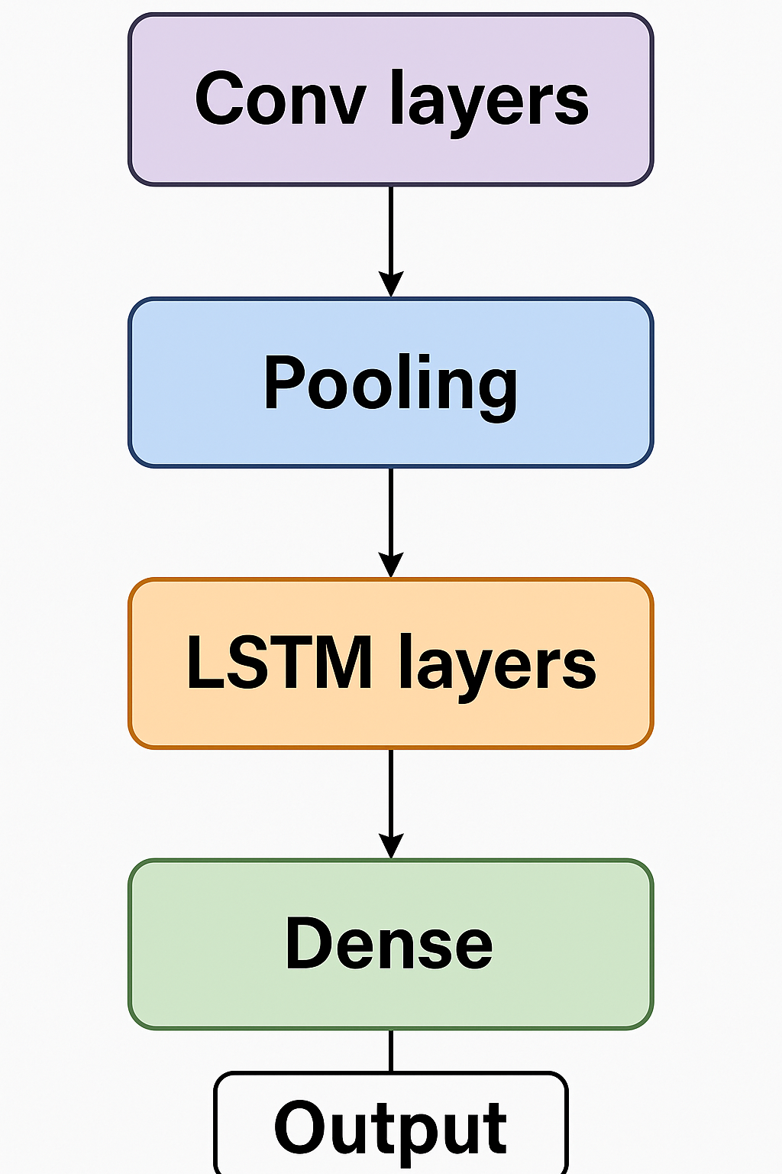
FIGURE 3.4 Training Process of the Model
PSEUDO CODE Used:

input_shape = X_train.shape[1:]
model = Sequential([
Dense(128, activation='relu', input_shape=input_shape),
Dropout(0.3),
Dense(64, activation='relu'),
Dropout(0.5),
Dense(2, activation='softmax')
])
model.compile(optimizer='adam', loss='categorical_crossentropy', metrics=['accuracy'])
model.fit(X_train, y_train, epochs=10, batch_size=64, validation_split=0.1)

3.5 Evaluation and Gender-Specific Testing
After training on mixed data, the model was evaluated in three separate testing scenarios:
- Mixed Test Data – to assess baseline performance on the same distribution as training.
- Male Test Data – to evaluate how well the model generalizes to male speakers only.
- Female Test Data – to evaluate generalization to female speakers only.
Performance metrics included accuracy, precision, recall, and F1-score, along with confusion matrices to visualize classification errors. This multi-level evaluation highlights the model’s robustness and uncovers potential gender-based performance biases.

3.6 Tools and Libraries
The entire pipeline was implemented in Python, using Google Colab for computation. Key libraries included Librosa for feature extraction, TensorFlow/Keras for deep learning modeling, Scikit-learn for evaluation metrics, and Pandas/Numpy for data handling. This combination allowed seamless preprocessing, training, and evaluation within a single environment.
import os
import numpy as np
import pandas as pd
import librosa
import matplotlib.pyplot as plt
from sklearn.model_selection import train_test_split
from sklearn.metrics import classification_report, confusion_matrix, ConfusionMatrixDisplay
from tensorflow.keras.models import Sequential
from tensorflow.keras.layers import Dense, Dropout
from tensorflow.keras.utils import to_categorical

CHAPTER 4: EXPERIMENTAL RESULTS AND DISCUSSIONS

4.1 Overview of Experiments
The experiments were conducted on the SEP-28k dataset using the proposed CNN-LSTM model. The key aim was to analyze how training on mixed-gender data performs when tested separately on mixed, male-only, and female-only subsets. The dataset was preprocessed by extracting 40-dimensional MFCC features with padding to 400 frames. The mixed data was split into 80% for training and 20% for testing, while male and female datasets were kept separate for cross-gender evaluation.
In the SEP-28K dataset there was no label for the gender. So we manually chose the dataset for male and female. After listening to the podcast we analyze that the podcast names HeStutter,StutterTalk,StrongVoices are in male voices and WomenWhoStutter, MyStutteringLife were in female voices. So we started giving labels of male female and mixed.
HeStutter and StutterTalk were assigned as Male and WomenWhoStutter as Female. The rest were known for mixed datasets.After doing this we got the count as:
Number of mixed gender clips: 10266
Number of male gender clips: 8748
Number of female gender clips: 9163

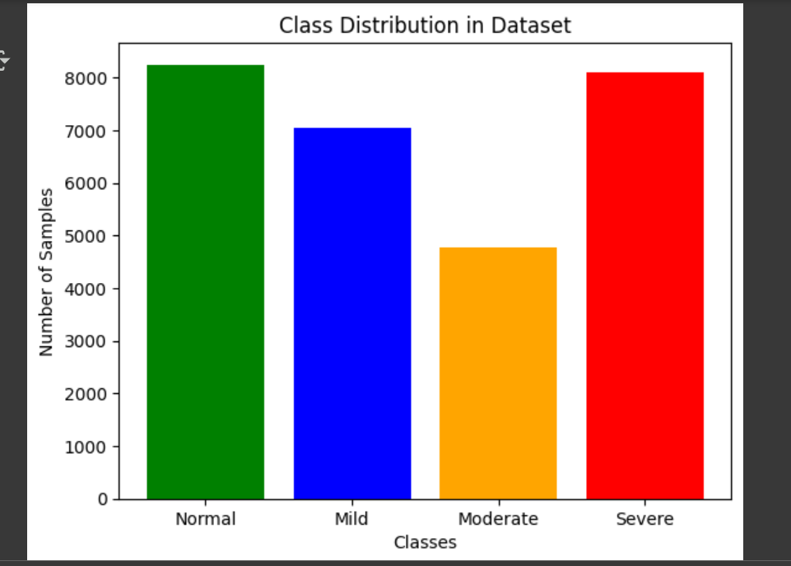
FIGURE 4.1 Class Distribution in Dataset
Also we have added one thing i.e we have worked on the severity labels. We have created 4 classes Normal,Mild,Moderate and Severe. We have labels in csv files of SEP-28K like Prolongation,WordRep,SoundRep and Block. We calculate the sum of all these of each audio file by adding a column Stutter Score.Stutter Score as follow:
If Stutter Score == 0 it is normal
If Stutter Score == 1 it is Mild Stuttering
If Stutter Score == 2 it is Moderate Stuttering
If Stutter Score == 3 it is Severe Stuttering

These are the number of normal audio files present in the dataset. According to each gender wise the count of normal audio files are:
Normal voice counts per gender:
Mixed 3363
Female 2444
Male 2439
4.2 Performance on Mixed Test Data
The trained model achieved 67% accuracy on mixed test data, indicating that training on combined male and female samples allows the model to capture general stuttering patterns effectively. Precision and recall values were balanced, meaning the model could correctly identify both stuttered and normal speech clips. However, the confusion matrix showed occasional misclassification of normal clips as stuttered, possibly due to silent pauses or breathing noises in speech.
Precision = 0.67 (67% of predicted stuttered clips were correct) Recall = 1.00 (model detected all actual stuttered clips) F1-score = 0.80 (balanced harmonic mean of precision and recall)

4.3 Performance on Male-Only Test Data
When tested on male-only audio clips, the accuracy slightly increased compared to mixed testing.Accuracy in this case is 72% This performance highlights that male voices have distinct pitch and acoustic characteristics that were less represented in the training set. Despite this, the model maintained reasonable recall for stuttered speech, meaning it still detected most stuttering events, but misclassified some fluent male speech.
Precision = 0.72 (72% of clips predicted as stuttered were actually stuttered) Recall = 1.00 (all stuttered clips were detected) F1-score = 0.84, indicating strong sensitivity to stuttered speech.

4.4 Performance on Female-Only Test Data
The female-only test results showed similar trends to male testing, with performance. Accuracy is shown to be 73%.Female voices typically have higher pitch and different prosodic features, which may not have been fully captured during training. This demonstrates a potential gender bias in the dataset and model, as training primarily on mixed data does not guarantee equal performance across genders.
Precision = 0.73 (73% of predicted stuttered clips were correct) Recall = 1.00 (model detected all stuttered clips)
F1-score = 0.85, showing strong detection capability for stuttering events.
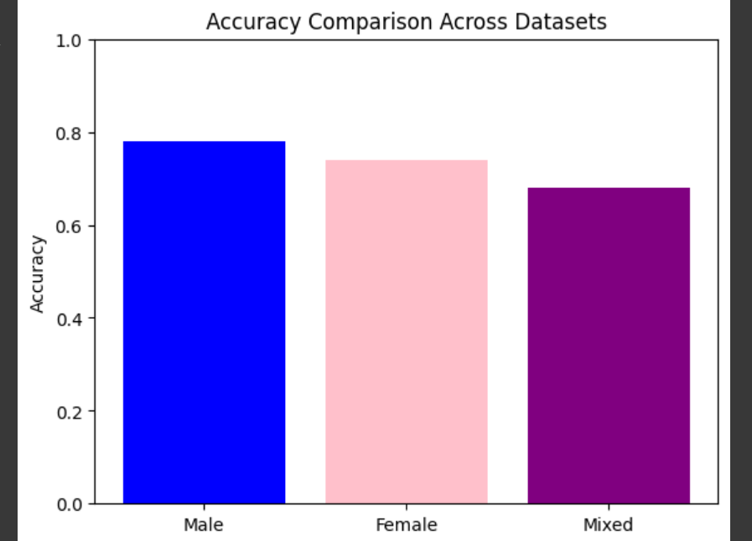

FIGURE 4.4 Accuracy Comparision Across Datasets

4.5 Comparative Discussion
- Mixed Training Advantage: Training on mixed data improves generalization but does not fully eliminate gender-specific variability.
- Model Strengths: CNN-LSTM captured both local (CNN) and sequential (LSTM) features of stuttering, outperforming traditional machine learning methods reported in earlier studies.
- Challenges: The model misclassifies some normal clips as stuttered, likely due to natural hesitations in fluent speech or background noise present in SEP-28k.The accuracy in the dataset is less as per my analysis is due to the less number of normal voices in the dataset. The model gives more accuracy if the number of stuttered clips are equal as normal but there is a huge difference in the count. So to increase the accuracy one should collect more data on normal voices.

4.6 Insights and Implications
These findings suggest that gender-aware training strategies could improve accuracy — for example, creating separate models for male and female voices or applying transfer learning. Additionally, data augmentation techniques (pitch shifting, noise addition) may further enhance robustness to acoustic variations. The results provide a foundation for real-world stuttering detection systems, especially in clinical or remote therapy applications where diverse voices are encountered.
4.7 Final Result
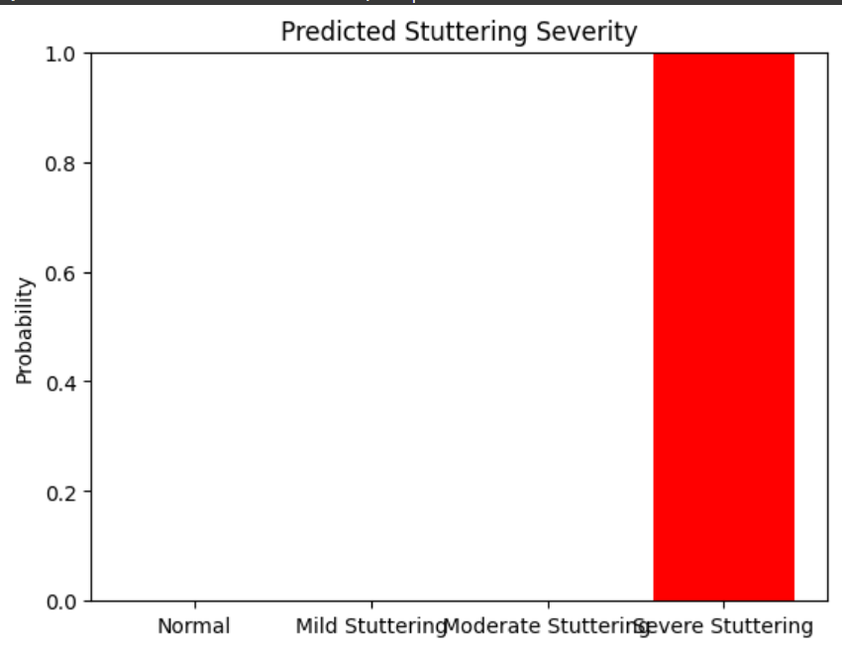
In our final model the output will give you two things, first the audio is normal or stuttered. If stuttered then it is severe, moderate or mild. Also it will tell through a graph the stuttering severity.

FIGURE 4.7 Predicted Stuttering Severity
In this we can see that the person is having a severe stuttering. We upload the audio file from the computer file and then it will predict the stuttering severity of a person.

CHAPTER 5: CONCLUSION AND FUTURE SCOPE
This project focused on the development of an AI-based stuttering detection system using the SEP-28k dataset. A hybrid CNN-LSTM model was implemented to classify speech into stuttered and normal categories. The dataset was preprocessed using MFCC features, and training was performed on mixed-gender data, with evaluations conducted separately on mixed, male, and female subsets.
The results demonstrated that the model achieved 67% accuracy on mixed data, 72% on male data, and 73% on female data. Across all test sets, the model showed perfect recall (1.00) for stuttered speech, meaning it never missed detecting stuttering events. However, the performance for normal speech detection was extremely low (recall = 0.00 for mixed and male datasets, and 0.01 for female), indicating a significant bias toward predicting stuttered speech. This imbalance likely arises from the unequal class distribution in SEP-28k, where stuttered samples vastly outnumber normal samples.
Despite this limitation, the project successfully demonstrates the potential of deep learning models in speech disorder detection. The CNN-LSTM architecture effectively captured both spectral features (via CNN) and temporal dependencies (via LSTM), providing a robust foundation for future work in automatic stuttering assessment.

Future Scope
To enhance model performance and applicability, several improvements are recommended:
- Class Balancing: Use data augmentation or weighted loss functions to handle imbalance between stuttered and normal speech samples.
- Gender-Specific Fine-Tuning: Train separate models for male and female voices or introduce gender-aware features to reduce bias.
- Cross-Dataset Validation: Combine SEP-28k with other datasets like FluencyBank or UCLASS for more diverse training and testing.
- Real-Time Implementation: Deploy the model in mobile or web-based tools for clinical or self-assessment use.
- Explainable AI (XAI): Incorporate interpretability methods (e.g., saliency maps) to visualize which parts of speech contribute to predictions.
This work lays the groundwork for automated stuttering detection systems that can support speech therapists and enable large-scale screening in schools and clinics. With further refinement, such AI tools have the potential to reduce diagnostic subjectivity, save time, and improve early intervention strategies for individuals with speech fluency disorders. We can also build an application software as doctors are unable to visit the rural areas. So this application will be very much helpful for the people in rural areas as they will understand the severity of stuttering of their voices and can work on it to cure the stuttering.

REFERENCES
- American Speech-Language-Hearing Association (ASHA). (n.d.). Stuttering (Fluency Disorders). Retrieved from https://www.asha.org/public/speech/disorders/stuttering/
- Bloodstein, O., & Ratner, N. B. (2008). A Handbook on Stuttering (6th ed.). Thomson Delmar Learning.
- Conture, E. G., & Curlee, R. F. (Eds.). (2007). Stuttering and Related Disorders of Fluency (3rd ed.). Thieme.
- National Institute on Deafness and Other Communication Disorders (NIDCD). (n.d.). Stuttering. Retrieved from https://www.nidcd.nih.gov/health/stuttering
- Yairi, E., & Ambrose, N. (2005). Early Childhood Stuttering: For Clinicians by Clinicians. Pro-Ed

Dataset
SEP-28k:
C. Lea, V. Mitra, A. Joshi, S. Kajarekar, and J. P. Bigham,“SEP-28k: A Dataset for Stuttering Event Detection from Podcasts with People Who Stutter,”in ICASSP 2021, pp. (if available), 2021. Available at Apple’s Machine Learning Research website.

Speech Classification with Deep Learning
- T. N. Sainath et al., “Convolutional, Long Short-Term Memory, fully connected Deep Neural Networks,” ICASSP 2015, pp. 4580–4584, 2015.
- A. Graves, A. Mohamed, and G. Hinton, “Speech recognition with deep recurrent neural networks,” ICASSP 2013, pp. 6645–6649, 2013.
- Nguyen,T.; Khadka, R.; Phan, N.; Yazidi, A.; Halvorsen, P.; Riegler, M.A. Combining datasets to increase the number of samples and improve model fitting. arXiv 2022, arXiv:2210.05165. Available online: http://arxiv.org/abs/2210.05165 (accessed on 15 March 2024).

Stuttering Detection Approaches using deep learning
- R. Riad, M. J. Gales, and J. Glass, “End-to-end stuttering event detection from raw waveform,” Interspeech 2021, pp. 1254–1258, 2021.
- A. Chetty and S. Roux, “Automatic stuttering detection using deep learning,” Journal of Fluency Disorders, vol. 64, pp. 105799, 2020.
- Nair, R. and Kannan, K.S., 2025. A Deep Learning-Based Guidance for Stuttering Prediction. Journal of Intelligent Systems & Internet of Things, 17(1).
- Abubakar, M., Mujahid, M., Kanwal, K., Iqbal, S., Asghar, M.N. and Alaulamie, A., 2024. Stutternet: Stuttering disfluency detection in synthetic speech signals via mel frequency cepstral coefficients features using deep learning. IEEE Access, 12, pp.99308-99320.
- Usler, E., 2025. A Predictive Processing Model of Stuttering and Cluttering Behavior.
- Alhakbani, N., Alnashwan, R., Al-Nafjan, A. and Almudhi, A., 2025. Automated stuttering detection using deep learning techniques. Journal of Clinical Medicine, 14(10), p.3552. Available at: https://doi.org/10.3390/jcm14103552
Other platform used
- www.goggle.com
- chatgpt.com
- googlescholar.com
- googlecolab.research.com

